
SYMBIOSIS INSTITUTE OF TECHNOLOGY, PUNE
Symbiosis International (Deemed University)
(Established under section 3 of the UGC Act, 1956)
Re-accredited by NAAC with ‘A’ grade (3.58/4) | Awarded Category – I by UGC
Founder: Prof. Dr. S. B. Mujumdar, M. Sc., Ph. D. (Awarded Padma Bhushan and Padma Shri by President of India)

Assignment No. 01

Subject: | DevOps Lab
TCODE: | TE7950
Name of Student | Yash Patel
PRN No. | 23070122235
Branch | CSE, Batch (2023-27), L4
Academic Year &  Semester | 23 – 27, Sem VII
Date of Performance | 16th July, 2026
Title of Assignment: | Git Setup & Basic Workflow
Theory: | Git is a distributed version control system that helps developers track changes in source code, collaborate efficiently, and maintain different versions of a project. GitHub is a cloud-based platform that hosts Git repositories and enables collaboration.  In this assignment, a GitHub repository was created and cloned to the local system. A README.md file was created, staged using git add, committed with git commit, and uploaded to GitHub using git push. This demonstrates the basic Git workflow for managing and synchronizing project files between a local machine and a remote repository.  Commands Used  - cd D:\CCodes – Navigated to the directory where the repository would be stored.  - git clone https://github.com/riavinod10/devops-lab.git – Cloned the remote GitHub repository to the local machine.  - cd devops-lab – Entered the cloned repository folder.  - echo "# DevOps Lab" > README.md – Created the README.md file with initial content.  - git status – Checked the repository status to verify that README.md was listed as an untracked file.  - git add README.md – Added the README.md file to the staging area.  - git status – Verified that the file was staged and ready to be committed.  - git commit -m "Add initial README.md file" – Created the first commit with a descriptive commit message.  - git status – Confirmed that the working tree was clean after the commit.  - git push origin main – Pushed the committed changes from the local repository to the remote GitHub repository.
Implementation: | Step 1: Create a New Repository on GitHub  Empty Repository on GitHub — Created an empty repository on GitHub without initializing it with a README, .gitignore, or license file to practice the Git local-to-remote workflow.  Step 2: Clone the Repository  Repository Cloned- Cloned the remote GitHub repository to the local machine using git clone and navigated into the project directory.  Step 3: Create README.md  Created README.md- Created the README.md file with initial content and verified using git status that Git recognizes it as an untracked file.  Step 4: Stage the File  Staged README.md- Added the README.md file to the staging area using git add and confirmed it is ready to be committed.  Step 5: Commit the Changes  Committed Changes- Created the first commit with a descriptive commit message and verified that the working tree is clean.  Step 6: Push to GitHub  Pushed to Remote Repository: Uploaded the local commit to the remote GitHub repository using git push.  Step 7: Verify on GitHub  Repository Verified: Verified on GitHub that the README.md file and the latest commit are visible, confirming the push was successful.  Assignment 1:  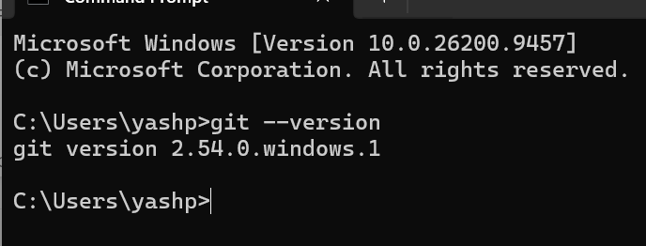  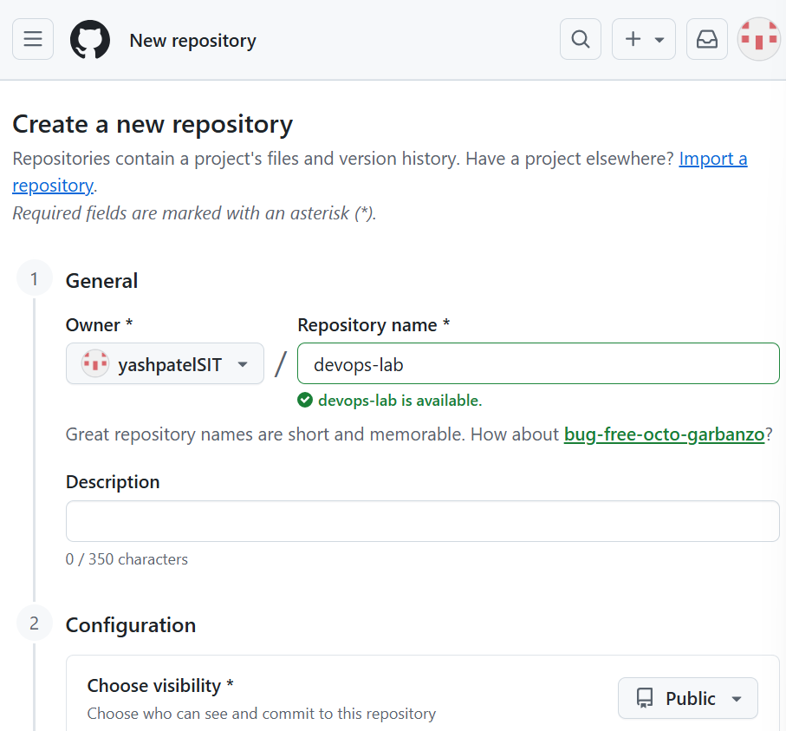  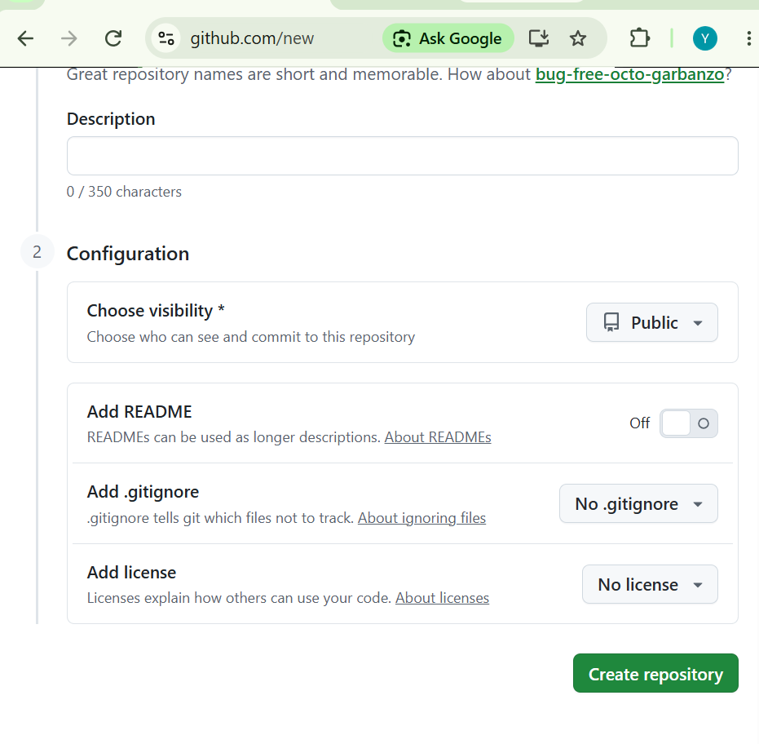  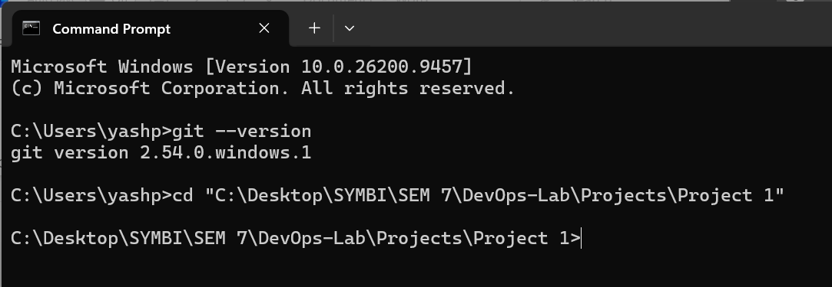  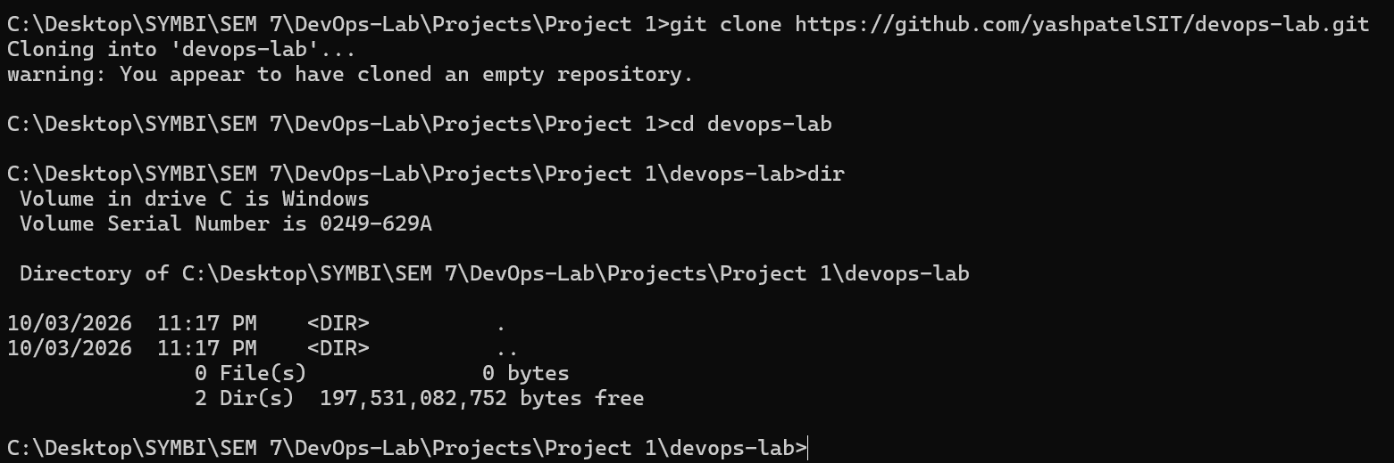  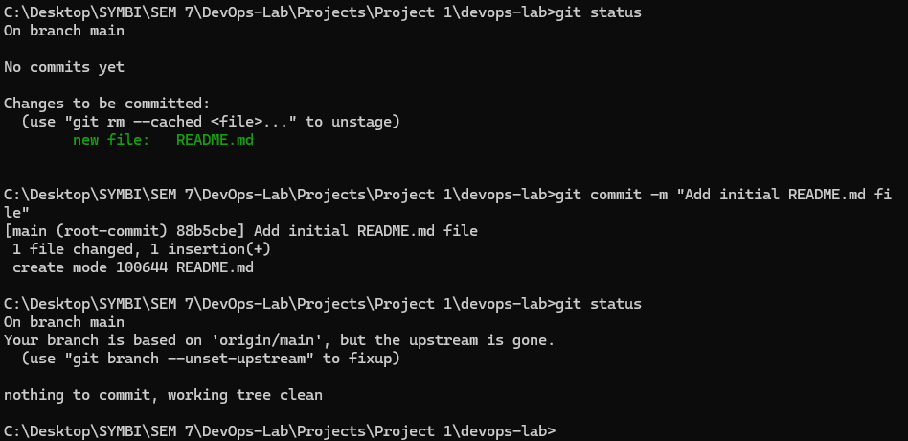  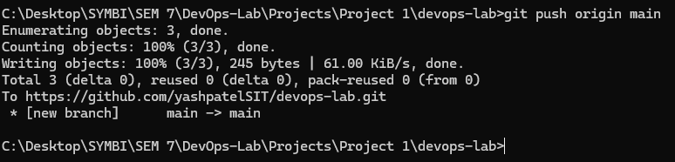  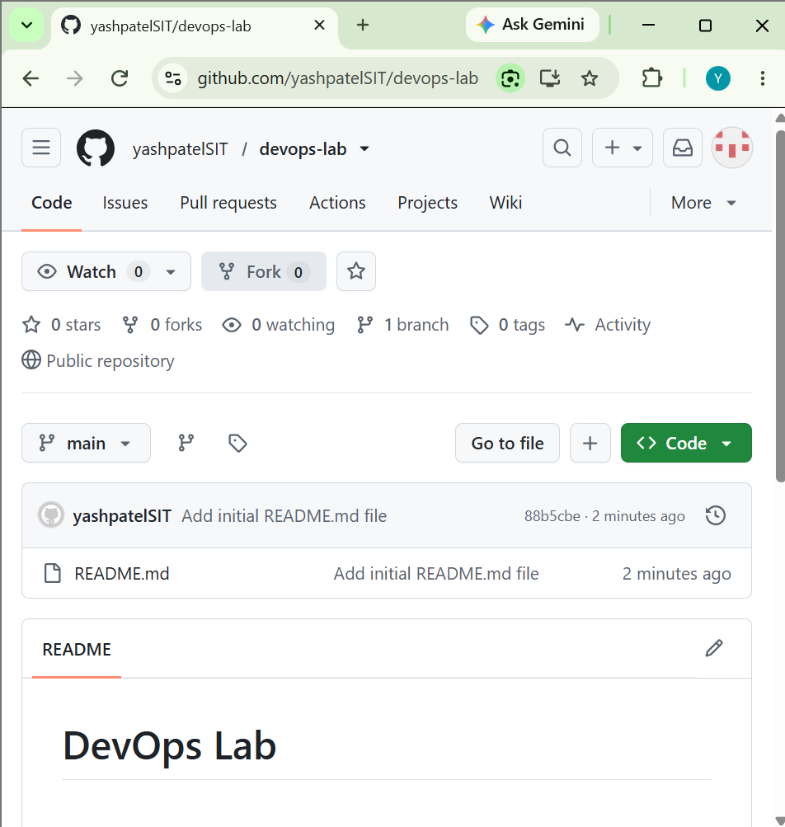

Subject Faculty Name: Prof. Arijit Dutta

